Exercise 1: Mocking and Stubbing

ExternalAPI.java
package junitdemo;
public interface ExternalApi {
String getData();
}

MyService.java

package junitdemo;
public class MyService {
private ExternalApi api;
public MyService(ExternalApi api) {
this.api = api;
}
public String fetchData() {
return api.getData();
}
}

OUTPUT

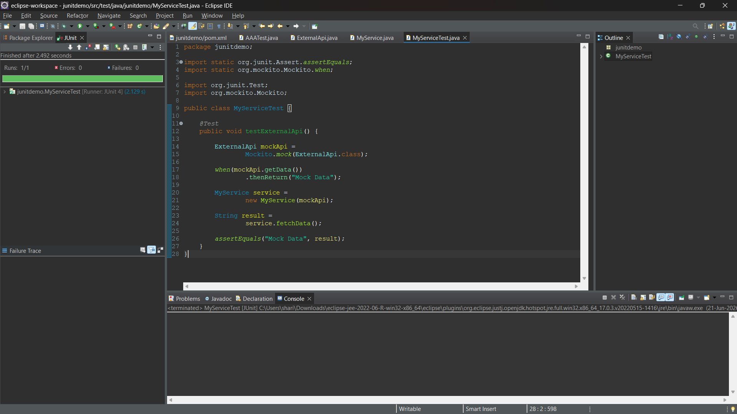
Exercise 2: Verifying Interactions

OUTPUT
